ABOUT CHIPPING DAY ON JULY 16TH

(Copied from AmadorRCD.org)

The ARCD will administer the Chipping Services Program through a grant awarded by the California Fire Safe Council. The “Neighborhood” program allows members of a neighborhood who live in the general vicinity of each other or on the same road to coordinate multiple addresses to be chipped on a set day (July 16th), usually with the assistance of a designated neighborhood lead (Vanessa 209-688-8629). The chipping programs are available to all Amador County residents who **first** pile vegetative slash along roadsides or driveways, **and then** submit a request for chipping.  The program will provide the community the ability to process vegetative debris, at no cost to the landowner.

Please contact Megan Watts with any questions or for further information:  
Email: megan@AmadorRCD.org  
Phone: 1-209-214-9727

REQUIREMENTS FOR CHIPPING DAY

The following requirements must be met in order for us to chip at your location. We reserve the right to refuse chipping services if these requirements are not met:

* Piles need to be stacked along a road or driveway frontages, which will allow the crew to work from the road or driveway.
* Piles must be placed within 5 feet of chipper access.
* Piles must be placed on level ground or on the uphill side of the road or driveway.
* Piles must be free of roots, stumps, rocks, mud, poison oak, scotch broom, blackberries and other vines.
* Piles must be stacked with the cut ends facing the same direction, pointing towards access route to piles. Heaviest materials should be on the bottom, lightest materials on the top.
* **Piles must not be higher than 5 feet and no wider than 10 feet long.** Multiple piles are allowed.
* Material can be up to **6 inches in diameter**, and needs to be**at least 3 feet in length (no longer than 10 feet).** The longer the better for the crew, as it is easier to feed through the chipper.
* **All chipped materials will be blown back onto the property or put in a pile where the brush was stacked.**
* The ARCD will provide service on a first-come, first–served basis.  **We limit service for individual customers to no more than 4 hours per visit.**
* The ARCD cannot clean up commercial properties, timber harvest projects, commercial projects, vacant lots, or marijuana grows.

PROHIBITED ITEMS

**The ARCD is not able to chip** foreign materials, non-vegetative items, or lumber of any kind:

* Piles of Leaves, Pine Needles, or Yard Clippings
* Poison Oak
* Decaying Wood
* All Varieties of Broom
* Commercial Properties, Timber Harvest Projects, Commercial Projects or Vacant Lots
* Blackberries/Vines/Anything with Thorns
* Root Balls, Stumps, Dirt, or Twigs​​

[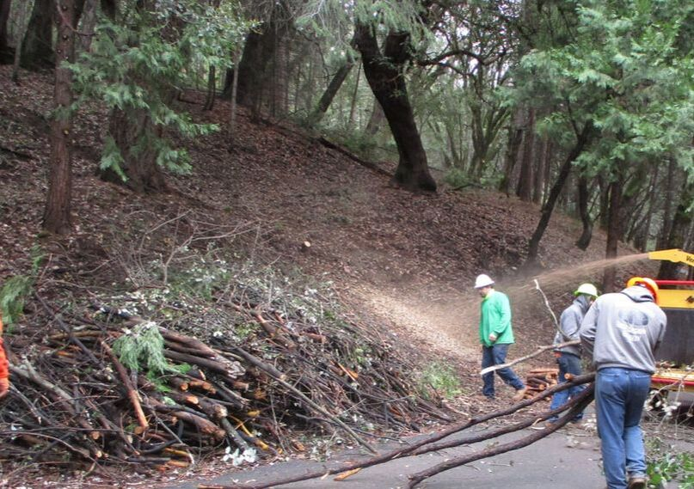](https://www.amadorrcd.org/uploads/1/2/2/0/122061759/edited/img-0363.jpg)

Image: 10 foot long and 3 feet high roadside pile of woody debris being chipped by contractor.

**Your piles should look like the one above. Improperly stacked or located piles may not be chipped.**

​Once you have completed the requirements listed above, complete and submit the “Request for Chipping” form.

DIRECTIONS TO COMPLETE THE “REQUEST FOR CHIPPING” FORM

Go to AmadorChipping.org **AFTER** your pile is staged for the chipper **and** at least 1 week prior to July 16th.

* Complete your personal contact information.
* Enter your specific chipper information.
* **For the question**: “Is this application part of a planned Neighborhood or Community Chipping Day?” Select “Yes”
* For “Community City” select “Other – Fill in your community name”.
* For “Community Name” Type “Sunset Heights”

Please contact Megan Watts with any questions or for further information:  
Email: megan@AmadorRCD.org  
Phone: 1-209-214-9727